**A DATA-DRIVEN EXPLORATION OF APPLE’S IPHONE IMPACT IN INDIA**

**INTRODUCTION:**

The first iphone was released in India in 2008. Apple’s sales in India hit a new high of about 6 billion dollars in the fiscal year, nearly 50% from a year earlier, showcasing the increasing importance of iphone in a country that emerged to be the fasted growing major economy.

**EMPATHY MAP**



**BRAINSTROMING**

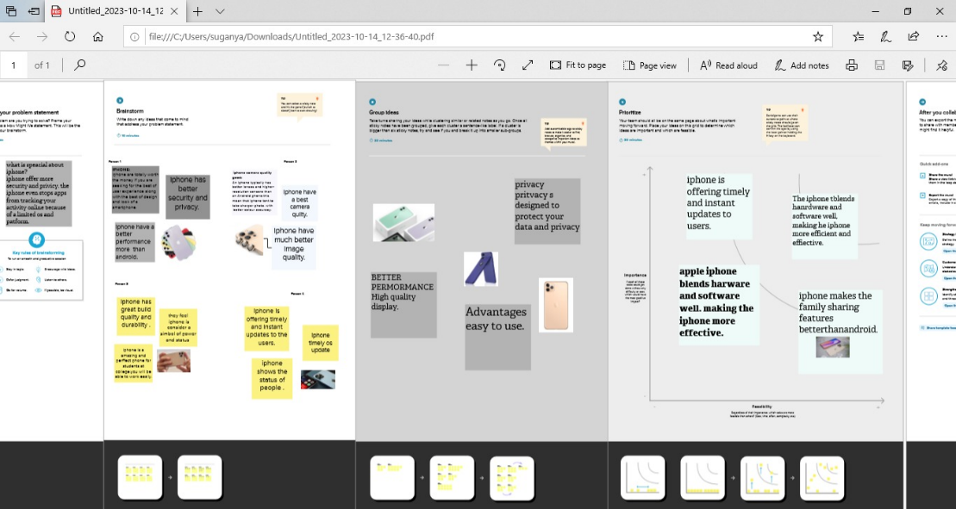

**DASHBOARD**



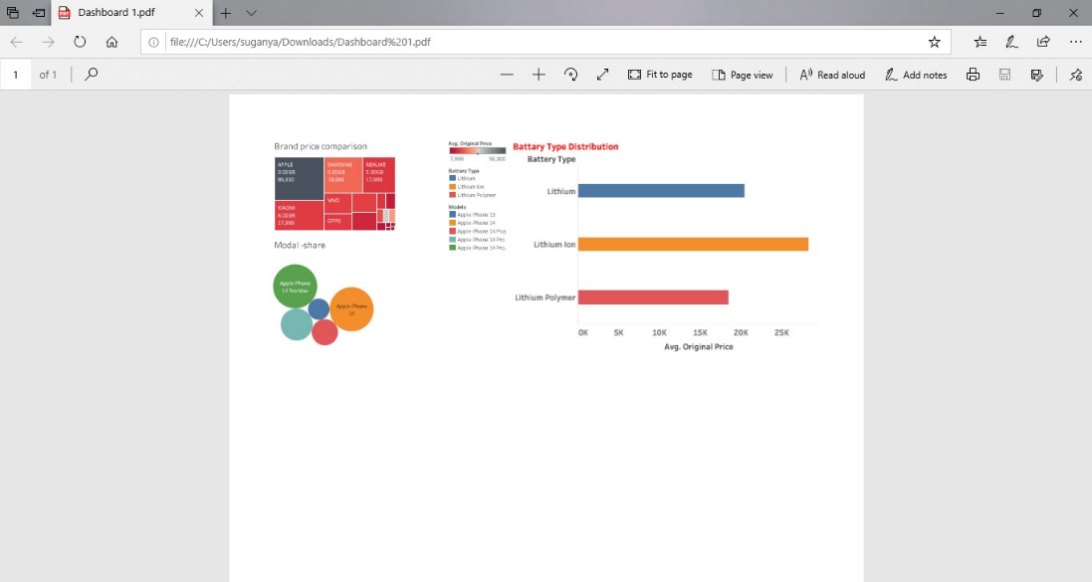

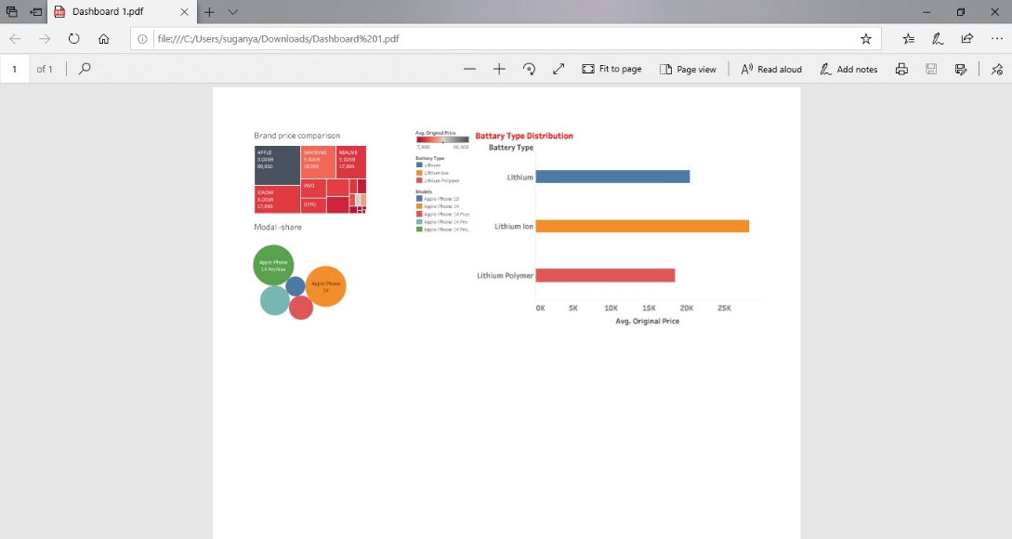

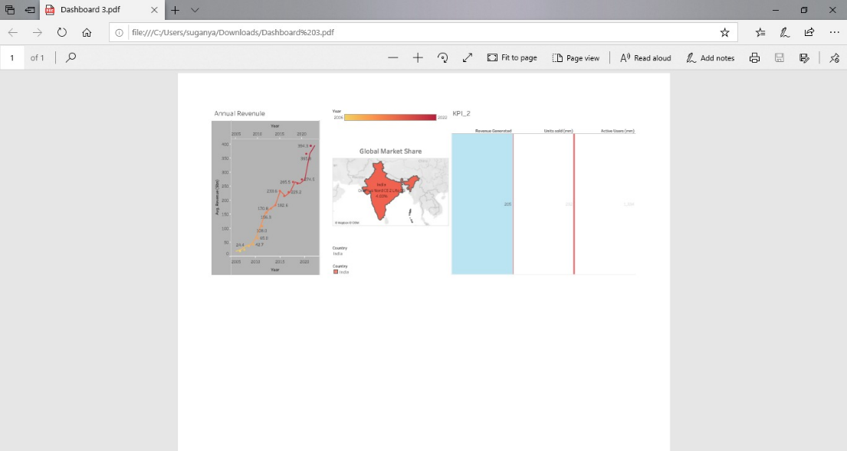

**STORY**



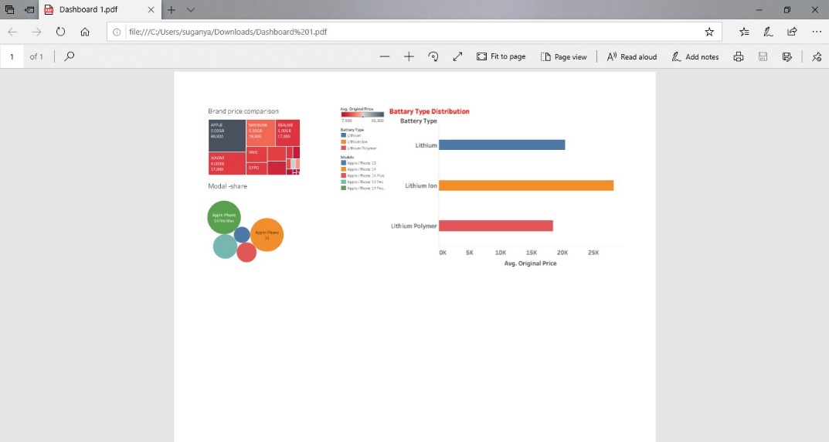

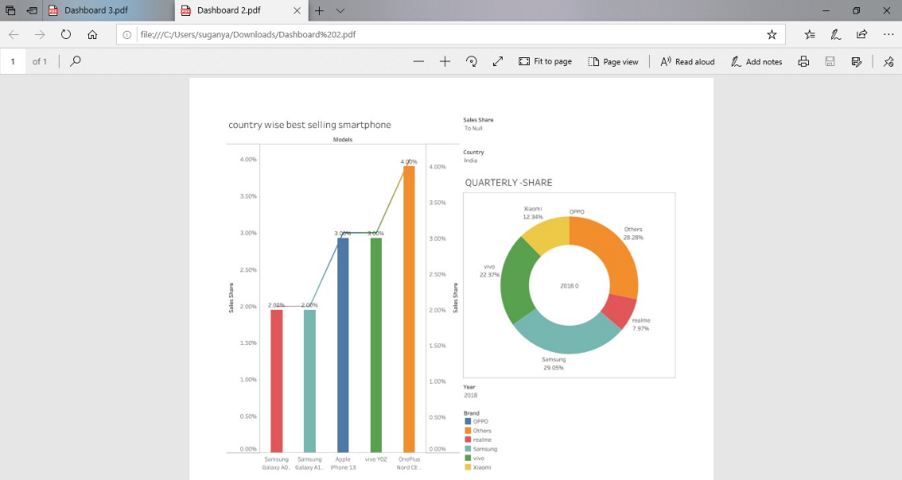

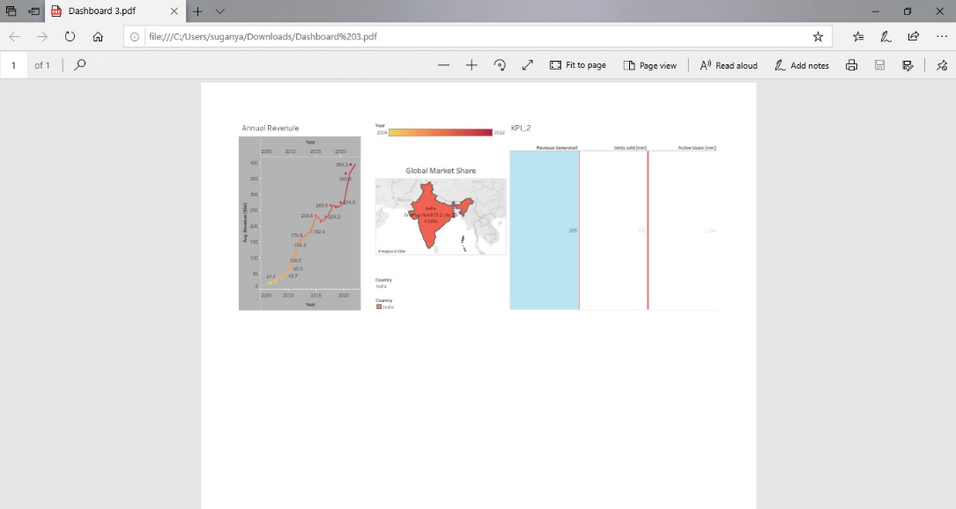

**ADVANTAGES OF APPLE IPHONE:**

1. Brand Value: Apple is known for its premium brand image and high-quality products which has attracted a significant number of Indian consumers who appreciate luxury and status symbols.

2. User Experience: iPhones offer a seamless and intuitive user experience with their iOS operating system. The interface is user-friendly visually appealing and comes with regular software updates ensuring a smooth and hassle-free smartphone experience.

3. App Ecosystem: The Apple App Store offers a wide range of high-quality applications that are curated and optimized for iOS devices. Users can access a variety of innovative and exclusive apps for productivity entertainment and more.

**DISADVANTAGES OF APPLE’S IPHONE:**

1. High Price: iPhones tend to be more expensive compared to other smartphones available in the Indian market. The premium pricing can make it unaffordable for a large section of the population limiting its accessibility.

2. Limited Customization: Apple's iOS limits the level of customization compared to Android. Users may have fewer options to personalize their device's appearance and functionality.

3. Dependency on Apple Ecosystem: iPhones work best when integrated with other Apple products and services such as Mac computers and iCloud. This can restrict flexibility for users heavily invested in non-Apple platforms.

**CONCLUSION**:

The data-driven exploration of Apple's iPhone impact in India allows us to assess its significance in various aspects such as market penetration consumer preferences economic impact and digital transformation. The findings can provide valuable insights for Apple and other smartphone manufacturers aiming to thrive in the Indian market. As India continues to be a lucrative market with exponential growth potential understanding the impact of Apple's iPhone will be crucial for future strategies and innovations.

**FUTURE SCOPE:**

In the future, the most important part of the iphone might be everything around it. In the short term, we are likely to see incremental improvements like higher quality cameras and giant displays.